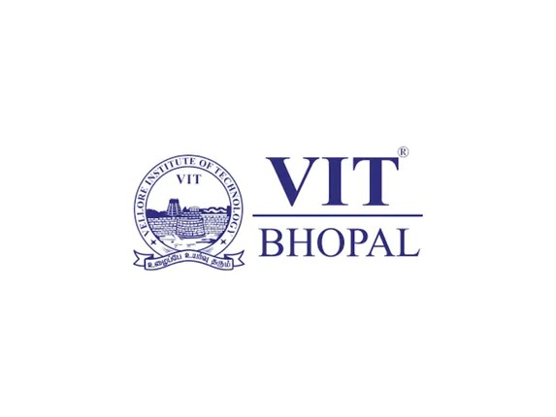

Digital literacy

PROJECT REPORT :

Name : Abisha Gladiya G

Reg No : 25BSA10047

Branch : BTECH CSE Cloud Computing and Automation

Year : First Year

Course Code : CSE0001- Digital Literacy

Date :

Introduction
Digital literacy is an essential skill in today’s technology-driven world. It refers to the ability to effectively use digital tools, platforms, and technologies for communication, learning, and professional development. As part of the Digital Literacy course, this project was designed to help students understand how to navigate the digital environment responsibly and productively. The project involved five tasks covering different aspects of digital literacy, including creating an awareness infographic, building a professional digital portfolio, exploring coding and collaboration platforms, practicing professional email communication, and studying cybercrime awareness. Each task helped develop practical skills useful for academic growth and future career opportunities.

TASK 1
For this task, I used Canva to create a digital literacy awareness infographic. Canva was easy to use because it provides ready-made templates, icons, and text formatting tools that helped me design the infographic neatly. My design mainly focuses on three important topics: what digital literacy is, safe internet practices, and useful digital tools for students. In the infographic, I explained that digital literacy means the ability to use digital devices, online platforms, and internet resources effectively and responsibly. I also included examples of useful tools such as GitHub, Google Forms, and LinkedIn that students can use for learning, collaboration, and building a professional profile. Another section of the infographic highlights safe internet practices like creating strong passwords, avoiding suspicious links, and protecting personal information online.
One interesting part of creating this design was selecting icons and arranging the content in a visually attractive manner so that it remains easy to read. The most difficult part was deciding how to include all the important points in a single slide without making it look crowded. Overall, this task helped me improve my creativity and digital presentation skills.

TASK 2;
I created profiles on GitHub, LinkedIn, and ResearchGate as part of my academic and professional development. Each platform serves a distinct purpose. GitHub is used for hosting and managing code, allowing me to showcase my programming projects and track my progress. LinkedIn helps in building a professional identity by displaying my education, skills, and achievements, while also enabling me to connect with professionals and explore career opportunities. ResearchGate is focused on academic collaboration, where researchers and students share papers, ask questions, and stay updated with recent developments in their field.
Over the next four years, I plan to use GitHub to regularly upload projects and improve my coding skills through practice and collaboration. On LinkedIn, I will maintain an updated profile, grow my network, and look for internships and job opportunities. On ResearchGate, I aim to explore research papers, gain knowledge in my field, and possibly share my own work in the future. These platforms will support my learning and career growth effectively.

TASK 3 :
For this task, I used HackerRank for coding practice and **Google Forms along with Google Sheets for collaboration and data collection. On HackerRank, I created an account and completed a beginner-level challenge, which helped me understand the basics of problem-solving and logical thinking. It gave me hands-on experience in applying programming concepts and improved my confidence in using online coding platforms.
For the collaboration part, I created a Digital Literacy Awareness Quiz using Google Forms with exactly five questions, including both multiple-choice and short-answer types. I also linked the form responses to Google Sheets, which helped me understand how responses can be automatically collected, organized, and analyzed in a spreadsheet format.
These tools will help me academically in many ways. HackerRank will support my coding practice and improve my technical skills for placements and internships. Google Forms and Sheets will be useful for conducting surveys, quizzes, feedback collection, and team projects during my academic journey. Overall, this task improved both my technical and collaborative digital skills.

Task 4
Poor digital communication can often lead to serious misunderstandings and delays. A common example is when a student sends an email to a professor without a clear subject line, proper greeting, or explanation of the issue. For instance, sending a message like “Please help, urgent” without mentioning the course name, assignment details, or reason for the request may confuse the professor and delay the response. This can result in missed deadlines or miscommunication.
Such situations can be avoided by following proper email etiquette. The email should include a clear subject line, a respectful greeting, a concise explanation of the problem, and a professional sign-off. In addition, the tone should remain polite and formal. Responsible social media use also plays a similar role in maintaining professionalism online. This task helped me understand the importance of clear, respectful, and well-structured digital communication in academic and professional environments.

TASK 5 :
While researching the topic of UPI and online payment fraud, what surprised me the most was how easily cybercriminals can trick people through fake links, QR codes, and phone calls that appear genuine. I found it alarming that many victims lose money simply by sharing an OTP or scanning a fraudulent QR code, especially when the scam creates urgency or pretends to offer rewards, scholarships, or refunds. This made me realize how important digital awareness is for students who frequently use online payment apps.
One habit I will personally change as a result of this research is that I will always verify the authenticity of links, payment requests, and QR codes before taking any action. I will also make it a strict rule never to share OTPs, UPI PINs, or banking details with anyone. Additionally, I will regularly check my transaction history and immediately report suspicious activity through cybercrime.gov.in or the 1930 helpline.

Conclusion
This project helped me understand the importance of digital literacy in modern academic and professional life. Through the five tasks, I learned how to create awareness content, build a digital portfolio, use online collaboration tools, communicate professionally, and stay safe from cyber threats. These skills are essential for students in today’s digital world.

References
Canva – https://www.canva.com
GitHub – https://github.com
LinkedIn – https://www.linkedin.com
Codechef - https://www.codechef.com/
Google Forms – https://forms.google.com
National Cyber Crime Portal – https://cybercrime.gov.in

